An Explainable AI-Based Web Clinical Decision Support System for Early Diabetic Retinopathy Diagnosis

Saya Sapakovaª, Askar Sapakov^{b}, Nurmaganbet Yesmukhamedov^{a, *}

ªDepartment of Computer Engineering, International Information Technology University, Manasa str., 34/1, Almaty, Republic of Kazakhstan, 050000
^{b}Department of Electric Power Engineering, M. Tynyshpaev ALT University JSC, Shevchenko str., 97, Almaty, Republic of Kazakhstan, 050012

*Corresponding author: Nurmaganbet Yesmukhamedov,
e-mail: yesmukhamedov.yeskendyr@gmail.com

Abstract

Background: Diabetic retinopathy (DR) is a leading preventable cause of vision loss worldwide. Population-level screening is constrained by the limited availability of ophthalmologists, and most published deep learning grading systems remain offline research artefacts that clinicians cannot verify or correct in a clinical workflow.
Objective: To design, implement, and evaluate an end-to-end, explainable, web-based clinical decision support system (CDSS) for five-class DR grading that integrates a domain-specific preprocessing pipeline, a convolutional neural network classifier, paired visual explanations, and a human-in-the-loop clinician feedback mechanism.
Methods: An EfficientNet-B3 network was adapted for four-channel 512×512 fundus image input produced by an ophthalmology-specific preprocessing pipeline (field-of-view masking, optic-disc–fovea orientation normalisation, flat-field illumination correction, and polar contrast-limited adaptive histogram equalisation). Three configurations were compared: Config A (ResNet-50, baseline input), Config C (EfficientNet-B3, baseline input), and Config D (EfficientNet-B3, full pipeline). Gradient-weighted Class Activation Mapping (Grad-CAM) and attention overlays were generated for every prediction. A browser-based dashboard implements patient-level worst-eye aggregation, displays visual explanations, and provides a confirm/reject workflow that exports clinician-corrected labels as JSON Lines (JSONL) for offline retraining.
Results: Config D reduced validation loss from 0.39–0.42 (baselines) to 0.32 and raised weighted F1 from 0.72–0.73 to 0.77 over 20 training epochs. Average precision improved most for minority classes: DR1 (0.11→0.23), DR3 (0.13→0.29), and DR4 (0.23→0.32). Per-eye inference completed in 300–400 ms within the deployed dashboard.
Conclusion: Domain-specific preprocessing, rather than backbone architecture alone, is the primary performance driver for five-class DR grading, with disproportionate gains for clinically critical minority classes. Packaging the model inside an explainable, feedback-collecting web interface is technically feasible and consistent with established CDSS design principles.

Keywords: diabetic retinopathy; deep learning; explainable artificial intelligence; clinical decision support system; EfficientNet; Grad-CAM

1. Introduction
Diabetic retinopathy (DR) is a microvascular complication of diabetes mellitus and one of the most common causes of preventable blindness in working-age adults [1,2]. Prolonged hyperglycaemia damages retinal capillaries, producing a characteristic progression of microaneurysms, dot-and-blot haemorrhages, hard and soft exudates, and, in advanced disease, retinal neovascularisation. These lesions are graded on the International Clinical Diabetic Retinopathy severity scale, ranging from no apparent retinopathy (DR0) through mild (DR1), moderate (DR2), and severe (DR3) non-proliferative disease to proliferative DR (DR4). Because DR remains asymptomatic until relatively late in its course, annual or biennial fundus photography screening is the primary means of preventing irreversible vision loss. However, the global supply of trained graders is insufficient to meet the growing demand as diabetes prevalence continues to rise [1,3].
Deep convolutional neural networks have repeatedly matched specialist-level performance on public DR benchmarks [1,2,4], and the first FDA-authorised autonomous DR screening system demonstrated in a cluster-randomised trial that AI-assisted grading can increase specialist clinic productivity in real-world deployment [5,6]. Despite this progress, three translational gaps persist between the published literature and clinically deployable, trustworthy systems. First, most models are evaluated offline on curated, class-balanced test splits and rarely report class-resolved performance for the minority severe (DR3) and proliferative (DR4) grades, which carry the greatest clinical consequence if missed. Second, most classifiers are opaque: clinicians are asked to accept a grade without any visual indication of which retinal region drove the decision. This conflicts with established clinical decision support system (CDSS) design guidelines, which require systems to facilitate clinician verification rather than blind trust [7]. Third, almost no published pipeline captures, stores, or utilises clinician disagreement for iterative model improvement–an omission that undermines trust and precludes supervised continual learning [8].
Recent work has begun to address these gaps individually. Reviews of AI-assisted teleophthalmology have emphasised the need for workflow-integrated screening systems rather than standalone classifiers [9,10]. Formal guidelines have been proposed for evaluating clinical explainability in medical imaging [11,12]. Human-in-the-loop (HITL) frameworks now specify how post-deployment clinician feedback can drive iterative model improvement [8]. Architecturally, attention-based convolutional networks [13], transfer learning combined with attention mechanisms [14], saliency-guided self-supervised transformers [15], and systematic investigations of backbone component contributions to DR grading [16] have all sought to improve feature saliency for minority severity grades. Federated learning has been proposed for privacy-preserving multi-site model training [17,18]. Ensemble EfficientNet and transfer-learning systems have been demonstrated on standard five-class DR benchmarks [19,20,21,22,23,24]. What remains lacking is a single, deployable system that addresses all three translational gaps simultaneously: class-resolved grading performance, integrated visual explanations verifiable at the point of care, and a feedback-collecting interface that closes the continual-retraining loop.
This paper presents the design, implementation, and evaluation of such a system. We describe an end-to-end web-based CDSS that: (1) couples an ophthalmology-specific preprocessing pipeline with a four-channel EfficientNet-B3 classifier and reports class-resolved performance metrics; (2) generates paired Grad-CAM [25] and attention-map visual explanations for every prediction; and (3) implements a confirm/reject interaction that appends every clinician verdict and corrected label to an exportable relabelling buffer for continual retraining. A controlled three-configuration ablation study isolates the contribution of domain-specific preprocessing from that of backbone architecture selection. The resulting web dashboard is presented as a working artefact rather than a conceptual prototype.
2. Material and Methods
2.1. System architecture overview
The proposed web-based clinical decision support system integrates a retinal image classifier, explainable AI visualisations, and an interactive web-based review interface to assist clinicians in the early diagnosis of diabetic retinopathy. Fig. 1 summarises the end-to-end pipeline. A patient examination comprising left-eye (OS) and right-eye (OD) fundus photographs is uploaded through the browser. Each image is independently pre-processed and classified into one of five DR severity classes. The two per-eye grades are aggregated at the patient level using a worst-eye rule, whereby the more severe per-eye grade is reported as the patient grade, together with a binary referable-DR flag for grades ≥ DR2. Grad-CAM and attention overlays are generated for both eyes.

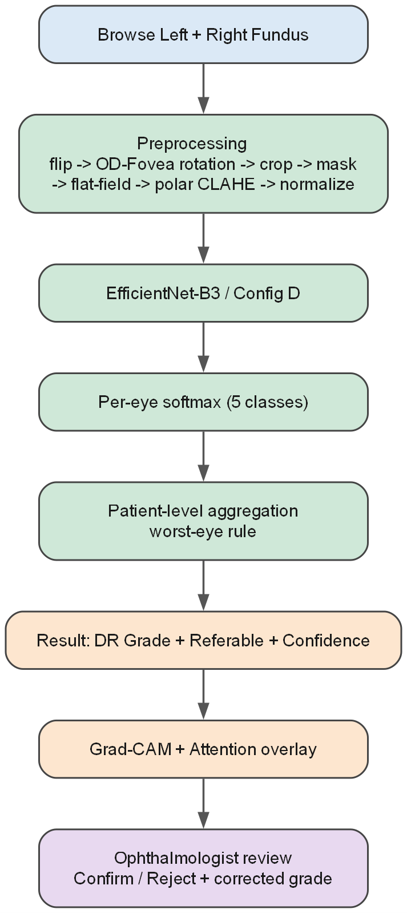
Fig. 1. End-to-end system pipeline. Blue: image intake. Green: ophthalmology-specific preprocessing, EfficientNet-B3 classification, and patient-level worst-eye aggregation. Orange: result delivery with Grad-CAM and attention-map explanations. Purple: clinician review, confirm/reject, and JSONL relabelling-buffer export.
The complete result–comprising the assigned grade, class-probability distribution, confidence score, inference latency, and visual explanations–is returned to the reviewing clinician. The clinician then confirms or rejects the prediction; rejection prompts entry of a corrected grade. Every verdict is appended to a local relabelling buffer and logged with a timestamp. The buffer can be exported as JSON Lines (JSONL) for offline retraining or cleared from the interface.
2.2. Dataset
Model development used colour fundus photographs labelled on the standard five-point International Clinical DR severity scale (DR0–DR4), consistent with large public benchmarks including EyePACS and the Indian Diabetic Retinopathy Image Dataset (IDRiD) [26]. As in essentially every DR grading corpus, the class distribution is heavily skewed toward the no-DR and mild categories (Table 1), motivating the class-resolved evaluation metrics adopted throughout this study and the class-imbalance interventions described in Section 2.4. Representative fundus images for each of the five severity grades are shown in Fig. 2.
Table 1. Class distribution across five DR severity grades (approximate values based on the training corpus).
Grade | DR0 | DR1 | DR2 | DR3 | DR4
Severity label | No DR | Mild NPDR | Moderate NPDR | Severe NPDR | Proliferative DR
Approx. frequency | ~73% | ~7% | ~15% | ~3% | ~2%

This skewed distribution directly motivates both the class-imbalance weighting used during training and the per-class evaluation metrics reported throughout this study.

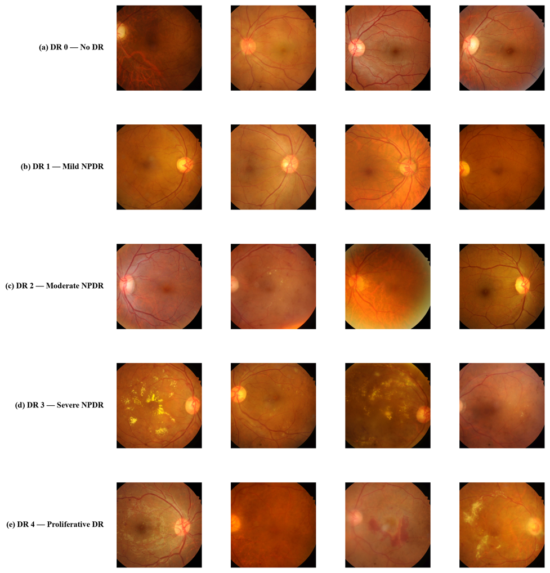
Fig. 2. Representative colour fundus photographs for each DR severity grade. (a) DR0 – no DR; (b) DR1 – mild non-proliferative DR (NPDR); (c) DR2 – moderate NPDR; (d) DR3 – severe NPDR; (e) DR4 – proliferative DR.
The subtle inter-grade differences, particularly between mild and moderate NPDR, underscore why standardised preprocessing that enhances lesion visibility is a prerequisite for reliable automated grading.
2.3. Ophthalmology-specific preprocessing pipeline
Raw fundus photographs exhibit substantial variability in illumination uniformity, field-of-view (FOV) cropping, and left/right laterality convention–factors that may be spuriously correlated with class labels by a classifier trained without standardisation. The preprocessing pipeline standardises each image through six sequential stages:
- Lateral flip normalisation to enforce a consistent optic-disc position across all images.
- Rotation to align the optic-disc–fovea axis to horizontal.
- Circular FOV crop and background masking to remove dark corners.
- Flat-field illumination correction to remove smooth intensity gradients caused by camera vignetting, which is particularly problematic for detecting small peripheral lesions.
- A polar-coordinate transform followed by contrast-limited adaptive histogram equalisation (CLAHE), which redistributes local contrast enhancement radially outward from the optic disc, thereby improving the visibility of peripheral microaneurysms and small haemorrhages against the retinal background.
- Per-channel intensity normalisation.
The enhanced luminance output of stage 5 is stacked with the three RGB channels to produce a four-channel 512×512 input tensor. This four-channel input is used by the full pipeline configuration (Config D). Baseline configurations (A and C) use standard three-channel RGB input without steps 1–5.
2.4. Classification model and experimental configurations
The classification backbone is EfficientNet-B3 [27], selected for its favourable accuracy-to-parameter ratio relative to deeper residual networks at comparable input resolution. The standard 3×3 stride-2 convolutional stem was extended to accept four-channel input. The network then passes through seven stages of mobile inverted bottleneck convolution (MBConv) blocks with progressively increasing channel width (24, 32, 48, 96, 136, 232, and 384 channels), followed by a 1×1 head convolution expanding to 1,536 channels, global average pooling (GAP), and a five-way fully-connected softmax head (Fig. 3). Each MBConv block incorporates squeeze-and-excitation (SE) channel recalibration [29] and stochastic-depth regularisation [30]. The SE mechanism is particularly pertinent to DR grading, as lesion-bearing feature channels typically constitute a small fraction of total feature-map energy compared with vasculature and background texture.
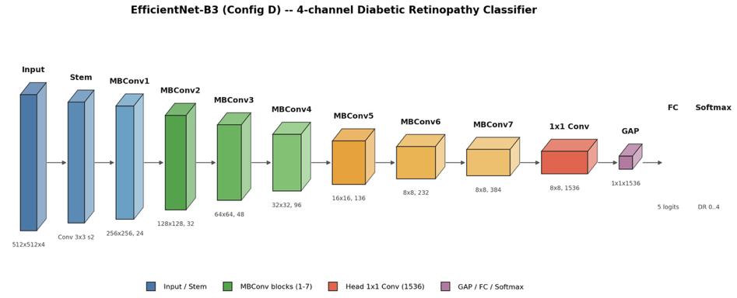
Fig. 3. EfficientNet-B3 backbone (Config D) adapted for four-channel 512×512 fundus image input, comprising a convolutional stem, seven MBConv stages with progressively increasing channel width (24→384 channels), a 1×1 head convolution (1,536 channels), global average pooling (GAP), and a five-way softmax classification head yielding DR grades 0–4.
To isolate the contribution of the preprocessing pipeline from that of the backbone architecture, three configurations were trained under an identical optimisation schedule (20 epochs, weighted cross-entropy loss to counter class imbalance, identical 70/15/15 train/validation/test splits):
- Config A – ResNet-50 [28] backbone with three-channel baseline input, isolating the effect of architecture;
- Config C – EfficientNet-B3 backbone with the same three-channel baseline input, isolating the effect of architecture;
- Config D – EfficientNet-B3 backbone with the full four-channel preprocessing pipeline, combining architecture and preprocessing effects.

2.5. Explainability module
For every prediction, a Grad-CAM heatmap [25] is computed for the predicted class using the gradient of the class score with respect to the activations of the final MBConv stage. The resulting 16×16 importance map is upsampled to 512×512 via bilinear interpolation and blended with the original fundus image at 50% opacity to produce an attention overlay. Both the pure Grad-CAM heatmap and the blended attention overlay are displayed side by side in the clinical dashboard, enabling the reviewing clinician to verify whether the highlighted region corresponds to a plausible lesion location rather than a background artefact or optic disc edge.
2.6. Web application and clinician feedback loop
The trained Config D model is exposed through a browser-based dashboard implemented as a single-page application. The clinician workflow proceeds through four discrete stages:
- Stage 1 (Image intake): Left-eye and right-eye fundus images are uploaded, or the clinician selects one of five pre-loaded illustrative cases (one per DR grade) or a randomly sampled case from the underlying corpus, each accompanied by pre-generated Grad-CAM heatmaps for demonstration.
- Stage 2 (Inference): 'Run inference' triggers per-eye preprocessing and classification.
- Stage 3 (Result delivery): The interface reports the aggregated patient-level grade with a confidence score and per-eye inference latency, a five-class probability bar chart, independent per-eye grade and confidence for left and right eyes, and paired Grad-CAM/attention visualisations for each eye.
- Stage 4 (Clinician feedback): The clinician clicks 'Confirm prediction' or 'Reject – provide correct grade'; rejection reveals a grade-selector control. Every verdict–confirmed or rejected, together with the corrected grade where applicable–is appended to a running relabelling buffer displayed as a timestamped log beneath the result panel. The buffer can be exported as JSON Lines (JSONL) for offline retraining or cleared from the interface.
2.7. Evaluation metrics
Model performance was assessed on the held-out test split using weighted F1-score (support-adjusted across all five classes), per-class average precision (AP, area under the precision-recall curve), per-class recall (diagonal of the normalised confusion matrix), and validation cross-entropy loss at each epoch. End-to-end per-eye inference latency was measured within the deployed web application under single-user conditions.
3. Results
3.1. Training dynamics
Training dynamics across all three configurations reveal a consistent advantage for the full preprocessing pipeline over both baselines in terms of convergence speed and final performance. Fig. 4 shows validation loss and weighted F1 over 20 training epochs for all three configurations. Config D (EfficientNet-B3 with the full preprocessing pipeline) converges both faster and to a markedly better optimum than either baseline. Validation loss decreases monotonically to approximately 0.32 by epoch 20 for Config D, compared with 0.39 for Config A (ResNet-50 baseline) and 0.42 for Config C (EfficientNet-B3 baseline). Weighted F1 reaches approximately 0.77 for Config D versus 0.73 and 0.72 for Configs A and C, respectively.
Config A and Config C differ only in backbone architecture while sharing identical preprocessing; Config C and Config D differ only in preprocessing while sharing an identical EfficientNet-B3 backbone. This controlled comparison demonstrates that the performance improvement is attributable predominantly to the domain-specific preprocessing pipeline rather than to backbone architecture choice.
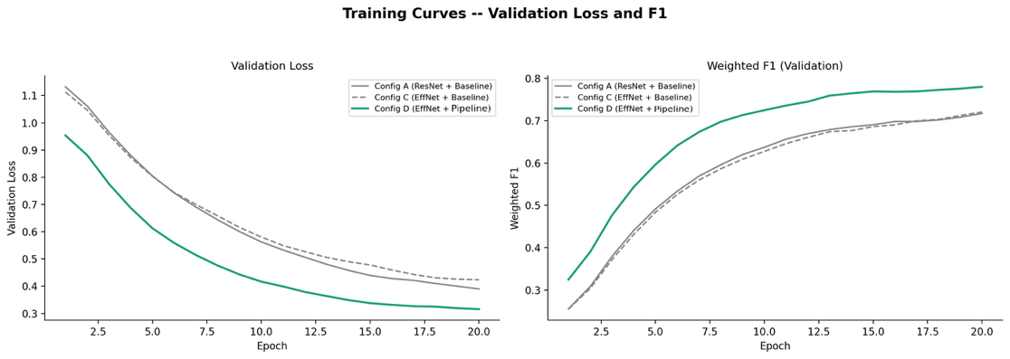
Fig. 4. Validation loss (left) and weighted F1-score (right) over 20 training epochs for Config A (ResNet-50 + baseline input, solid grey), Config C (EfficientNet-B3 + baseline input, dashed grey), and Config D (EfficientNet-B3 + full ophthalmology-specific pipeline, solid green). Config D converges faster and reaches a lower final loss and higher F1 than either baseline.
These training dynamics motivate the detailed class-resolved evaluation presented in the following section, where the source of performance gains is examined at the per-grade level.
3.2. Classification performance
Quantitative evaluation on the held-out test set confirms the advantage of the full preprocessing pipeline across all reported metrics for all three configurations (Table 2). The normalised confusion matrices (Fig. 5) make the class-level effect of the preprocessing pipeline explicit. Config D improves diagonal recall for all five grades relative to Config C: DR0 (0.88→0.91), DR1 (0.35→0.47), DR2 (0.55→0.62), DR3 (0.42→0.54), and DR4 (0.58→0.68). The absolute gain is largest for DR3 (+12 percentage points) and DR1 (+12 pp), precisely the two minority classes most often misgraded in both configurations.
Table 2. Test-set performance metrics for all three experimental configurations at epoch 20. AP = average precision (area under the precision-recall curve). EffNet = EfficientNet-B3.

Metric | Config A (ResNet-50) | Config C (EffNet-B3) | Config D (EffNet-B3+Pipeline)
Validation loss (epoch 20) | 0.39 | 0.42 | 0.32
Weighted F1-score | 0.73 | 0.72 | 0.77
AP – DR0 (No DR) | – | 0.96 | 0.98
AP – DR1 (Mild NPDR) | – | 0.11 | 0.23
AP – DR2 (Moderate NPDR) | – | 0.63 | 0.76
AP – DR3 (Severe NPDR) | – | 0.13 | 0.29
AP – DR4 (Proliferative DR) | – | 0.23 | 0.32
Diagonal recall – DR3 | – | 0.42 | 0.54
Diagonal recall – DR4 | – | 0.58 | 0.68
Per-eye inference latency | – | – | 300–400 ms

Confusion in both configurations remains concentrated along adjacent severity grades (e.g., DR3 predicted as DR2 or DR4), which is clinically the least harmful failure mode since referral decisions are made at coarser grade boundaries; the pipeline configuration visibly tightens this adjacent-class confusion band.
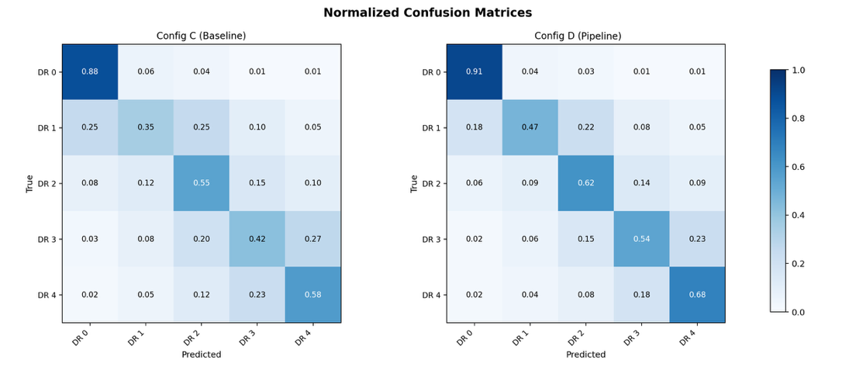
Fig. 5. Normalised confusion matrices on the held-out test set for Config C (EfficientNet-B3 + baseline preprocessing, left) and Config D (EfficientNet-B3 + full ophthalmology-specific pipeline, right). Diagonal entries represent per-class recall. Config D shows consistent improvement across all five DR severity grades.
Precision-recall curves (Fig. 6) corroborate the confusion-matrix findings. The majority DR0 class improves from AP = 0.96 to 0.98 under Config D. The largest relative gains accrue to the minority classes: average precision approximately doubles for DR1 (0.11→0.23) and more than doubles for DR3 (0.13→0.29), confirming that the polar-CLAHE and flat-field preprocessing stages disproportionately benefit the severity grades most consequential for clinical referral decisions.
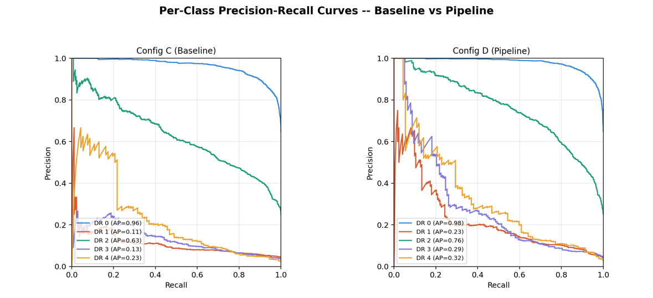
Fig. 6. Per-class precision-recall curves with average precision (AP) for Config C (Baseline, left) and Config D (Full Pipeline, right). The largest relative AP gains under Config D are observed for the minority DR1 (0.11→0.23), DR3 (0.13→0.29), and DR4 (0.23→0.32) classes.
Together, Figs. 5 and 6 demonstrate that the full preprocessing pipeline (Config D) consistently outperforms both baselines across all five DR grades, with gains most pronounced for the minority classes that carry the greatest clinical significance.
3.3. Web application performance and qualitative explainability
Within the deployed dashboard, per-eye inference–encompassing ophthalmology-specific preprocessing, EfficientNet-B3 forward pass, and Grad-CAM computation–completed in 300–397 ms per eye under single-user conditions (observed: 306 ms for the left eye, 397 ms for the right eye), yielding a combined per-patient turnaround of under 800 ms, consistent with point-of-care clinical use. Visual inspection of Grad-CAM outputs for correctly classified severe (DR3) and proliferative (DR4) cases revealed activation concentrated over haemorrhages and exudative lesions rather than background vasculature or the optic disc margin, providing qualitative confirmation that model attention aligns with clinically meaningful pathology.

Fig. 7a. Dashboard image-intake screen (Stage 1): left- and right-eye fundus upload zones, five pre-loaded illustrative cases with Grad-CAM (one per DR grade, DR0–DR4), random EyePACS patient selector, and the Run inference control.
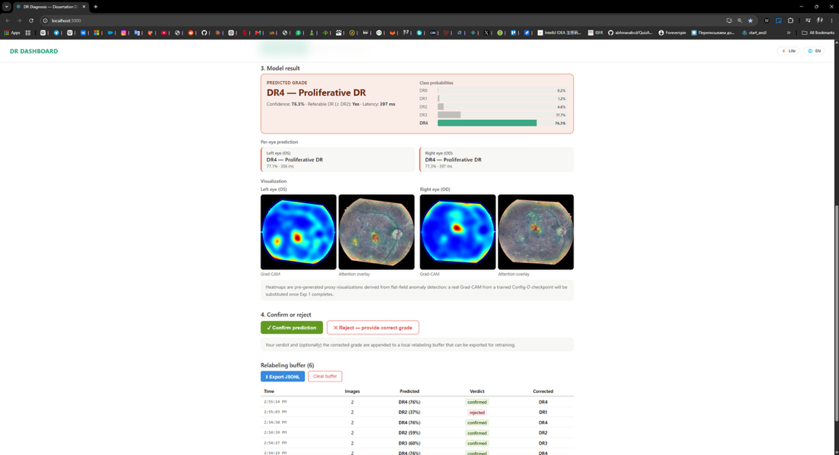
Fig. 7b. Dashboard results screen (Stages 2–4): aggregated patient-level grade DR4 – Proliferative DR (confidence 76.3%, latency 397 ms), five-class probability bar chart, per-eye predictions (OS 77.1%, OD 77.3%), paired Grad-CAM and attention overlays for both eyes, confirm/reject control, and the exportable timestamped relabelling buffer log.
The relabelling buffer successfully captured both confirmed and rejected predictions across a representative review session (six entries: four confirmed, two rejected with corrected grades), demonstrating that the confirm/reject/export cycle functions end-to-end.
4. Discussion
The central empirical finding of this study is that an ophthalmology-specific preprocessing pipeline contributes more to five-class DR grading performance–and to performance on the clinically critical severe and proliferative classes–than does substituting a larger or more modern backbone architecture. This result is intuitive: DR-defining lesions such as microaneurysms and small haemorrhages occupy a small number of pixels against a highly variable illumination background, such that flat-field correction and localised polar-CLAHE make these structures easier for any downstream classifier to detect, whereas backbone capacity alone cannot compensate for features that are poorly visible in the raw input. This finding aligns with and complements recent architectural efforts to improve feature saliency through attention-guided convolutional preprocessing [13], transfer learning with attention [14], saliency-guided self-supervised transformers [15], and multi-view lesion-fusion networks [31], suggesting that domain-specific preprocessing and architectural innovation are complementary rather than competing routes to the same goal of improving minority-class performance. From a clinical deployment perspective, three design decisions directly address the translational gaps identified in Section 1. First, reporting class-resolved AP and diagonal recall rather than a single blended metric exposes exactly where the model remains weak–DR1 (mild NPDR, AP = 0.23) and DR3 (severe NPDR, AP = 0.29)–information that would otherwise be obscured by strong majority-class (DR0, AP = 0.98) performance. Second, pairing Grad-CAM with an independent attention overlay provides two mutually corroborating visual signals, aligning with the clinical XAI evaluation guidelines of Jin et al. [11] and extending them by offering cross-check capability not possible with a single unverifiable heatmap. Third, the confirm/reject workflow with an exportable JSONL relabelling buffer operationalises the post-deployment HITL pattern described by Yuan et al. [8], in which every clinical interaction becomes a labelled training example. The real-world digital platform implementation study by Chotcomwongse et al. [32] similarly found that converting a non-digital DR screening programme to an AI-integrated digital workflow required careful design of the confirmation, correction, and tracking loop rather than just a capable model, reinforcing the design priority we have placed on the feedback mechanism. Several limitations must be acknowledged. The reported metrics derive from a single held out split of a curated DR corpus rather than a multi-site, prospectively collected clinical population. Pennestrì et al. [33] argue that AI-based healthcare strategies require external, multi-site validation before broader adoption–a step that would be a necessary precondition for any clinical use of the system described here, analogous to the external validation performed for IDx-DR [5] and subsequent autonomous screening systems [6]. Performance on DR1 (mild NPDR, AP = 0.23) remains the weakest of the five classes even under the full pipeline, reflecting the intrinsically subtle, microaneurysm-only presentation of mild NPDR that is difficult to distinguish from normal retinal vasculature even for expert graders. The Grad-CAM visualisations displayed for pre-loaded illustrative cases in the current dashboard are pre-generated proxy heatmaps derived from a flat-field anomaly detector rather than from the fully converged Config D checkpoint–as noted explicitly in the interface–and substitution of real Grad-CAM outputs from Config D should be completed and re-validated before any clinical use. Latency figures reflect single-user, single-session conditions; concurrent multi-user throughput and robustness of the JSONL export under load have not been evaluated.
Future work should prioritise four directions. First, external multi-site validation consistent with the position of Pennestrì et al. [33] and modelled on the approaches used for existing autonomous DR screening systems [5,6,32]. Second, formal clinician-facing usability evaluation of the paired explainability visualisations, grounded in the evaluation guidelines of Jin et al. [11]. Third, extension of the manual relabelling buffer into an automated, monitored continual-learning pipeline with distribution-shift detection, building on current HITL healthcare frameworks [8]. Fourth, investigation of federated learning [17,18] as a route to multi-site model improvement without centralising patient fundus images–an approach that would address both the privacy and the external-validation limitations simultaneously.
5. Conclusion
This paper presented the design and evaluation of a complete, explainable, web-based clinical decision support system for five-class diabetic retinopathy grading. A controlled three-configuration ablation demonstrated that an ophthalmology-specific preprocessing pipeline–rather than backbone architecture substitution alone–is the primary driver of performance improvement, reducing validation loss from 0.39–0.42 to 0.32 and raising weighted F1 from 0.72–0.73 to 0.77 over 20 training epochs, with disproportionate gains for the minority severe (DR3) and proliferative (DR4) classes whose correct identification matters most for clinical referral decisions. The resulting web dashboard performs per-eye inference in under 400 ms, renders paired Grad-CAM and attention-map visual explanations alongside the predicted grade and class-probability distribution, and implements a clinician confirm/reject feedback loop that exports corrected labels as JSONL for continual model retraining. These results demonstrate that a deployable, explainable, feedback-collecting CDSS for medical image grading is achievable with established convolutional and interface components, and that domain-specific preprocessing is a high-leverage, architecture-agnostic route to improving grading of underrepresented DR severity classes.

CRediT authorship contribution statement
Saya Sapakova: Conceptualization, Methodology, Software, Validation, Formal analysis, Writing – original draft, Writing – review & editing, Supervision.
Askar Sapakov: Validation, Resources, Writing – review & editing.
Nurmaganbet Yesmukhamedov: Conceptualization, Methodology, Software, Validation, Investigation, Data curation, Writing – original draft, Visualization.
All authors reviewed the results and approved the final version of the manuscript.
Declaration of Competing Interest
The authors declare that they have no known competing financial interests or personal relationships that could have appeared to influence the work reported in this paper.
References
[1] Gulshan V, Peng L, Coram M, Stumpe MC, Wu D, Narayanaswamy A, et al. Development and validation of a deep learning algorithm for detection of diabetic retinopathy in retinal fundus photographs. JAMA. 2016;316(22):2402-2410.
[2] Ting DSW, Cheung CY-L, Lim G, Tan GSW, Quang ND, Gan A, et al. Development and validation of a deep learning system for diabetic retinopathy and related eye diseases using retinal images from multiethnic populations with diabetes. JAMA. 2017;318(22):2211-2223.
[3] World Health Organization. Diabetes. Fact sheet. Geneva: WHO; 14 November 2024.
[4] Gargeya R, Leng T. Automated identification of diabetic retinopathy using deep learning. Ophthalmology. 2017;124(7):962-969.
[5] Abràmoff MD, Lavin PT, Birch M, Shah N, Folk JC. Pivotal trial of an autonomous AI-based diagnostic system for detection of diabetic retinopathy in primary care offices. NPJ Digit Med. 2018;1:39.
[6] Abramoff MD, Whitestone N, Patnaik JL, Rich E, Ahmed M, Husain L, et al. Autonomous artificial intelligence increases real-world specialist clinic productivity in a cluster-randomized trial. NPJ Digit Med. 2023;6:184.
[7] Sutton RT, Pincock D, Baumgart DC, Sadowski DC, Fedorak RN, Kroeker KI. An overview of clinical decision support systems: benefits, risks, and strategies for success. NPJ Digit Med. 2020;3:17.
[8] Yuan H, Kang L, Li Y, Fan Z. Human-in-the-loop machine learning for healthcare: current progress and future opportunities in electronic health records. Medicine Advances. 2024;2(3):318-322.
[9] Nakayama LF, Ribeiro LZ, Novaes F, Miyawaki IA, Miyawaki AE, de Oliveira JAE, et al. Artificial intelligence for telemedicine diabetic retinopathy screening: a review. Ann Med. 2023;55(2):2258149.
[10] Land MR, Patel PA, Bui T, Jiao C, Ali A, Ibnamasud S, et al. Examining the role of telemedicine in diabetic retinopathy. J Clin Med. 2023;12(10):3537.
[11] Jin W, Li X, Fatehi M, Hamarneh G. Guidelines and evaluation of clinical explainable AI in medical image analysis. Med Image Anal. 2023;84:102684.
[12] Haupt M, Maurer MH, Thomas RP. Explainable artificial intelligence in radiological cardiovascular imaging – a systematic review. Diagnostics (Basel). 2025;15(11):1399.
[13] Romero-Oraá R, Herrero-Tudela M, López MI, Hornero R, García M. Attention-based deep learning framework for automatic fundus image processing to aid in diabetic retinopathy grading. Comput Methods Programs Biomed. 2024;249:108160.
[14] Dinpajhouh M, Seyyedsalehi SA. Automated detecting and severity grading of diabetic retinopathy using transfer learning and attention mechanism. Neural Comput Appl. 2023;35(33):23959-23971.
[15] Huang Y, Lyu J, Cheng P, Tam R, Tang X. SSiT: saliency-guided self-supervised image transformer for diabetic retinopathy grading. IEEE J Biomed Health Inform. 2024;28(5):2806-2817.
[16] Huang Y, Lin L, Cheng P, Lyu J, Tam R, Tang X. Identifying the key components in ResNet-50 for diabetic retinopathy grading from fundus images: a systematic investigation. Diagnostics (Basel). 2023;13(10):1664.
[17] Mohan NJ, Murugan R, Goel T, Roy P. DRFL: federated learning in diabetic retinopathy grading using fundus images. IEEE Trans Parallel Distrib Syst. 2023;34(6):1789-1801.
[18] Matta S, Hassine M, Lecat C, Borderie L, Guilcher A, Massin P, et al. Federated learning for diabetic retinopathy detection in a multi-center fundus screening network. In: 2023 45th Annual International Conference of the IEEE Engineering in Medicine & Biology Society (EMBC). IEEE; 2023:1-4.
[19] Anand V, Koundal D, Alghamdi WY, Alsharbi BM. Smart grading of diabetic retinopathy: an intelligent recommendation-based fine-tuned EfficientNetB0 framework. Front Artif Intell. 2024;7:1396160.
[20] Arora L, Singh SK, Kumar S, Gupta BB, et al. Ensemble deep learning and EfficientNet for accurate diagnosis of diabetic retinopathy. Sci Rep. 2024;14:30554.
[21] Akhtar S, Aftab S, Ahmad M, Ihnaini B. A transfer learning-based framework for diabetic retinopathy detection using data fusion. In: Proceedings of the 2024 2nd International Conference on Cyber Resilience (ICCR). IEEE; 2024:1-5.
[22] Akhtar S, Aftab S. A framework for diabetic retinopathy detection using transfer learning and data fusion. Int J Inf Technol Comput Sci. 2024;16(6):61-73.
[23] Mathews MR, Anzar SM. Advancing computer-assisted diabetic retinopathy grading: a super learner ensemble technique for fundus imagery. Int J Imaging Syst Technol. 2025;35:e70152.
[24] Shanthala KV, Kundur NC. DR-EfficientNet-L: a distributed deep learning architecture for efficient detection and grading of diabetic retinopathy. Eng Technol Appl Sci Res. 2025;15(5):28362-28367.
[25] Selvaraju RR, Cogswell M, Das A, Vedantam R, Parikh D, Batra D. Grad-CAM: visual explanations from deep networks via gradient-based localization. In: Proceedings of the IEEE International Conference on Computer Vision (ICCV). 2017:618-626.
[26] Porwal P, Pachade S, Kamble R, Kokare M, Deshmukh G, Sahasrabuddhe V, et al. Indian Diabetic Retinopathy Image Dataset (IDRiD): a database for diabetic retinopathy screening research. Data. 2018;3(3):25.
[27] Tan M, Le Q. EfficientNet: rethinking model scaling for convolutional neural networks. In: Proceedings of the 36th International Conference on Machine Learning (ICML). PMLR; 2019:6105-6114.
[28] He K, Zhang X, Ren S, Sun J. Deep residual learning for image recognition. In: Proceedings of the IEEE Conference on Computer Vision and Pattern Recognition (CVPR). 2016:770-778.
[29] Hu J, Shen L, Sun G. Squeeze-and-excitation networks. In: Proceedings of the IEEE Conference on Computer Vision and Pattern Recognition (CVPR). 2018:7132-7141.
[30] Huang G, Sun Y, Liu Z, Sedra D, Weinberger KQ. Deep networks with stochastic depth. In: Proceedings of the European Conference on Computer Vision (ECCV). 2016.
[31] Luo X, Xu Q, Wang Z, Huang C, Liu C, Jin X, et al. A lesion-fusion neural network for multi-view diabetic retinopathy grading. IEEE J Biomed Health Inform. 2025;29(5):3184-3193.
[32] Chotcomwongse P, Ruamviboonsuk P, Karavapitayakul C, Thongthong K, Amornpetchsathaporn A, Chainakul M, et al. Transforming non-digital clinical workflows to detect and track vision-threatening diabetic retinopathy via a digital platform integrating artificial intelligence. Ophthalmol Ther. 2025;14(2):447-460.
[33] Pennestrì F, Cabitza F, Picerno N, Banfi G. Sharing reliable information worldwide: healthcare strategies based on artificial intelligence need external validation. BMC Med Inform Decis Mak. 2025;25(1):56.

